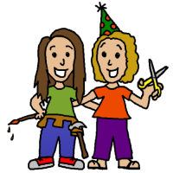

Presented by
Chica and Jo

Tailgating checklist

To use this document:
- Print out the list check off the items as you pack them.
- This list is by no means comprehensive; add any items to the list that are personal to you. Update this file when you return from your tailgating party adding items you wish you had packed and subtracting items you never needed.

For more information or more project tips, please visit us at

http://chicaandjo.com
Tailgating Checklist
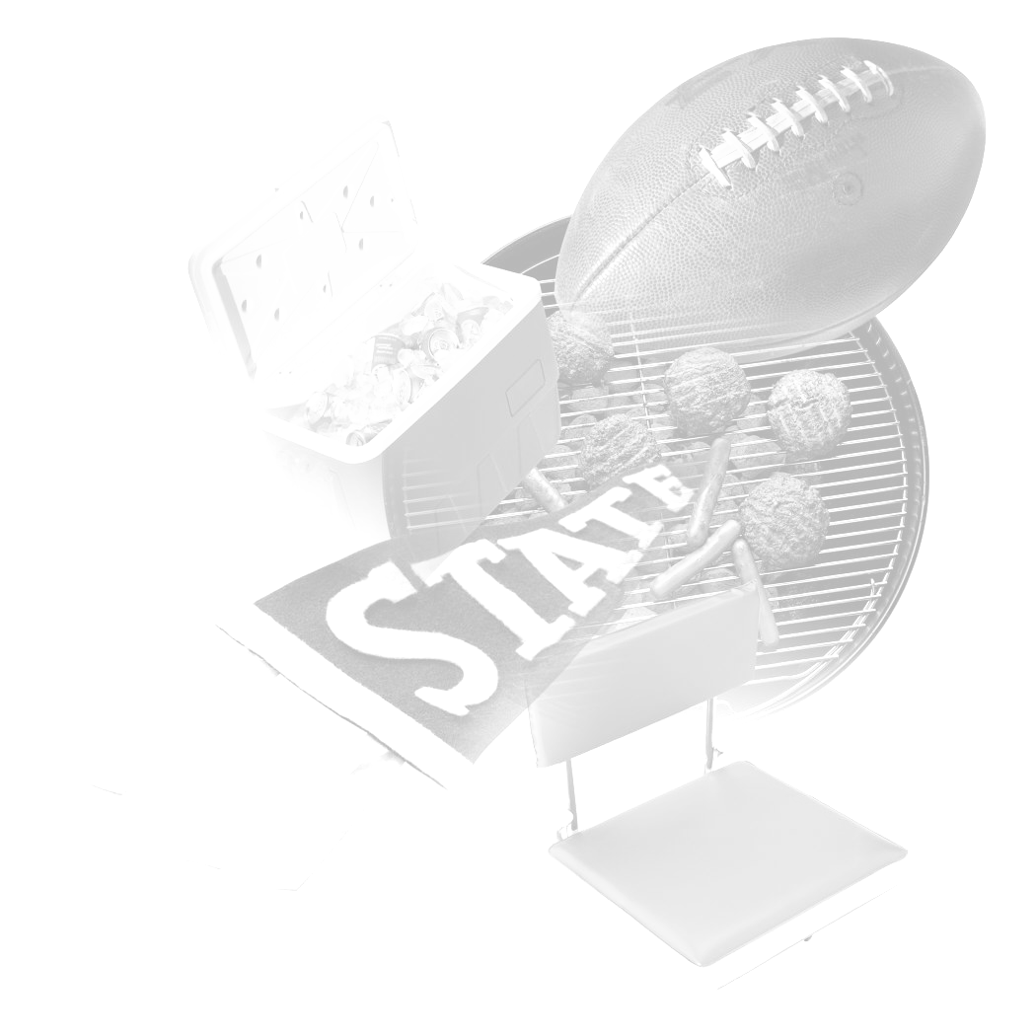
- Tent/canopy  - Disposable table cloths  - Folding chairs  - Table  - Grill, gas or charcoal & lighter fluid  - Matches  - Ice  - Coolers  - Cooking utensils (grilling tools, spoon, all-purpose knife)  - Forks, knives, spoons  - Plates, cups  - Napkins  - Disposable foil pans  - Pots, if needed  - Pot holders  - Trash bags for trash as well as recyclables  - Paper towels/wet wipes  - Bottle/can/wine opener  - First aid kit  - Fire extinguisher  - Television/Radio  - Batteries  - Ziploc bags | - Games: corn hole, football, cards  - Stadium blankets  - Camera  - Rain gear  - Beverages (soda, beer, water, juice)  - Kerosene heater  - Sun block  - Antacid  - Game tickets  - Toothpicks  - Themed decorations  - Anti-bacterial gel  - Extension cords  - Sharpie (for labeling cups/plates)  - ______________________________  - ______________________________  - ______________________________  - ______________________________  - ______________________________  - ______________________________  - ______________________________  - ______________________________  - ______________________________  - ______________________________  - ______________________________  - ______________________________

